**Pythagorean Theorem and Its Applications**

The most famous theorem in geometry is the Pythagorean Theorem. Although the credit for discovering and formalizing the theorem goes to the brilliant Greek mathematician Pythagoras, its applications and use cases can be traced back much further and to various parts of the world. Let’s explore what the Pythagorean Theorem is all about and examine some of its practical applications.

### **The Pythagorean Theorem**

The Pythagorean theorem, describing the relationship between the three sides of a right triangle, is attributed to the ancient Greek mathematician and philosopher Pythagoras. In a right triangle, the Pythagorean theorem applies, stating that the square of the length of the hypotenuse is equal to the sum of the squares of the lengths of the other two sides. This relationship is fundamental in solving problems involving right triangles.

There are several proofs for the Pythagoras theorem. Below is a visual proof of the theorem:

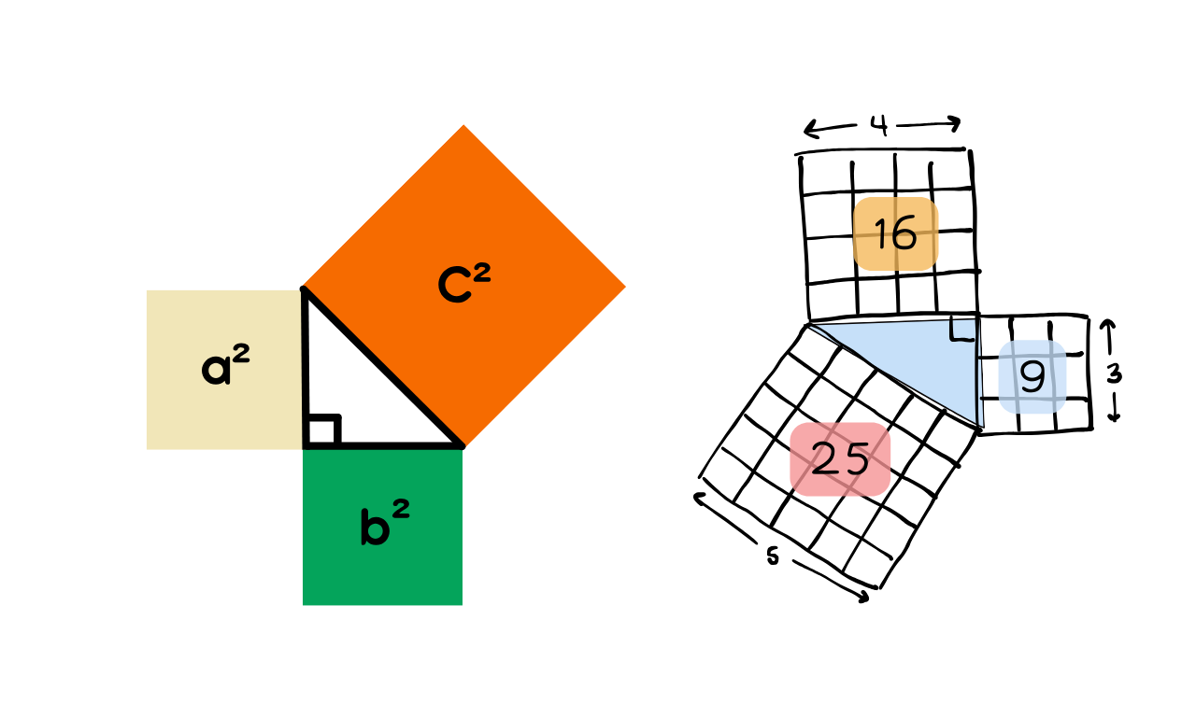

**Applications of the Pythagorean Theorem**

The Pythagorean theorem finds practical applications, with its most straightforward use being the determination of the missing side of a right triangle. It allows for the calculation of the third side when two sides of a right triangle are known. The example below shows a right triangle with a height of 9 inches and a hypotenuse of 15 inches. The base can be determined as shown:

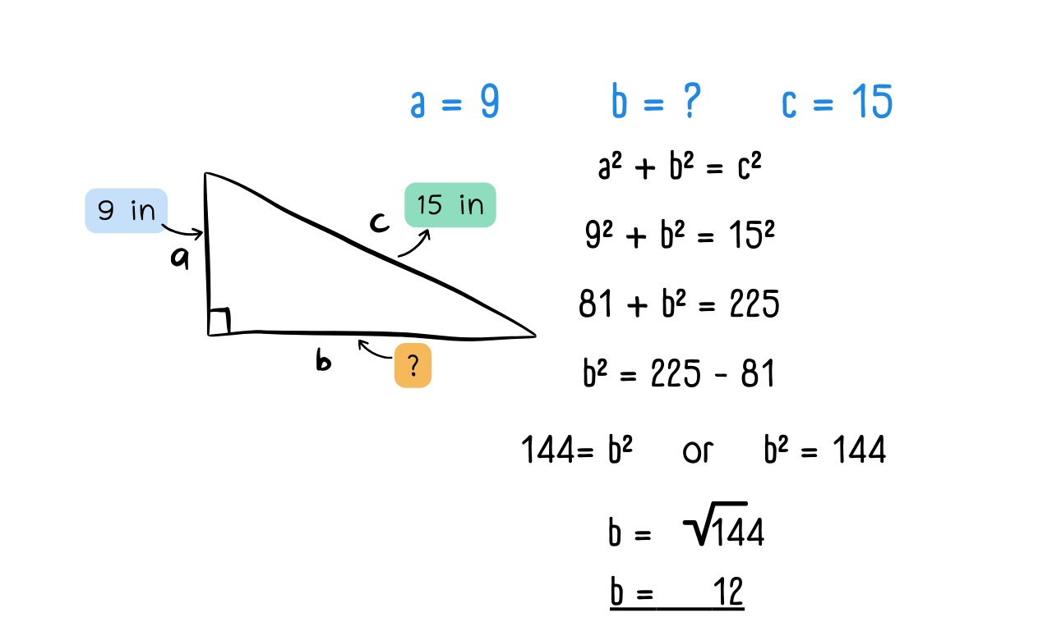

Some real-life applications that extend from this use case are the following:

* Finding the distance between two points on the Cartesian plane.

Let’s we want to find the shortest distance between (1,6) and (8,-3) on the cartesian plane.

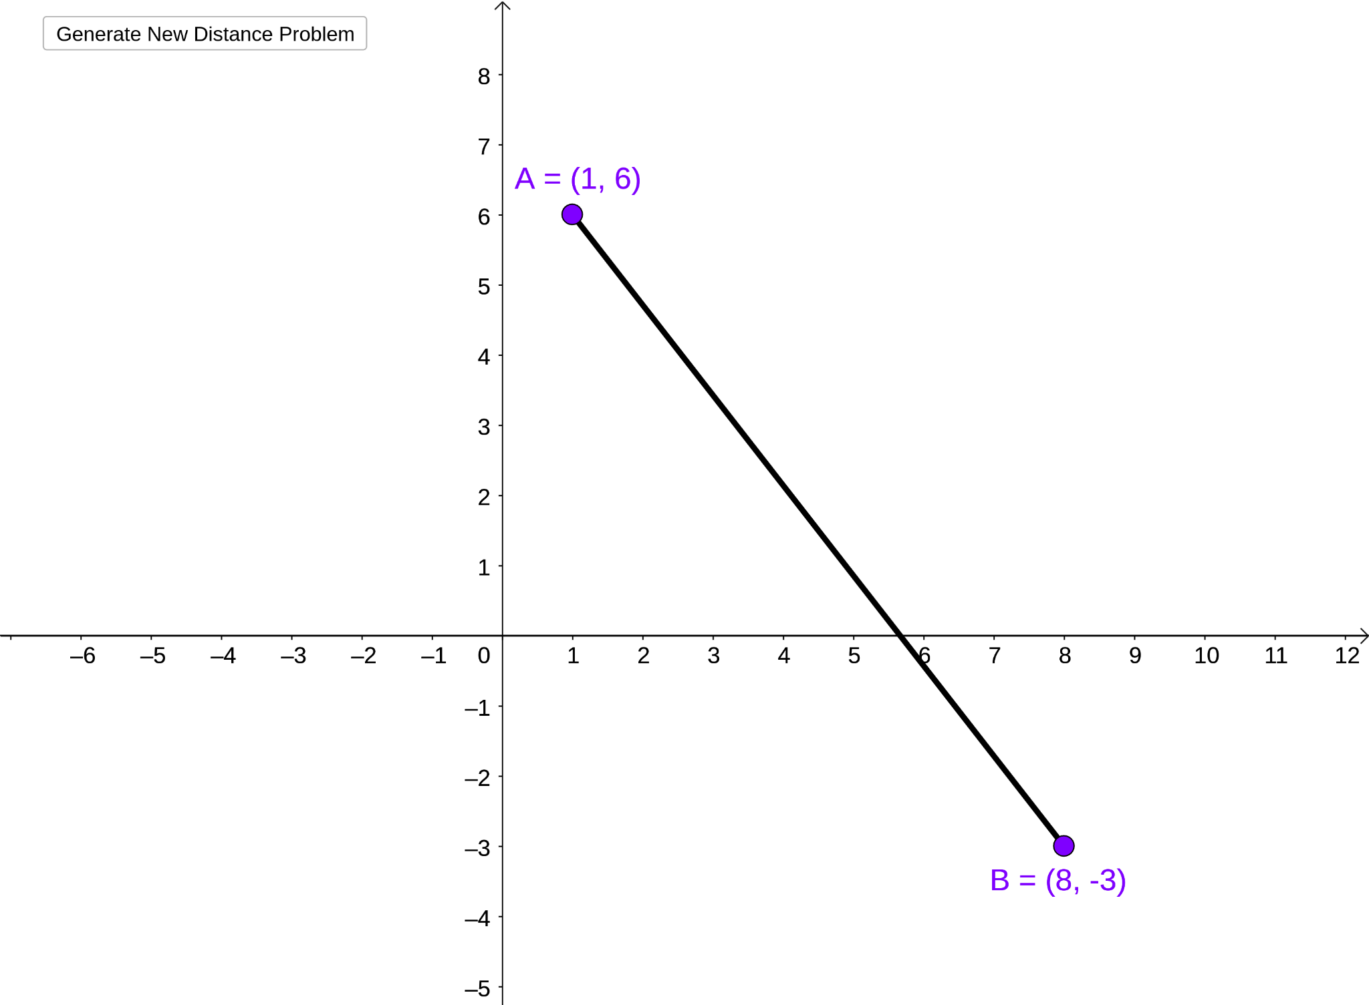

We can construct a right angle with the side AB as the hypotenuse.

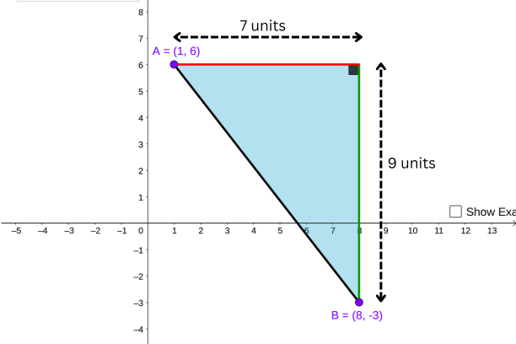

This construction will make the application of the Pythagoras theorem apparent:

The height and width of the triangle can be found by calculating the difference between the y-coordinates (6 - -3 = 9), and x-coordinates (8-1 = 7) respectively.

Applying the Pythagoras theorem we get:

* Determining the maximum height a ladder can reach.

Imagine you have a ladder that is 17ft long. You need to set the base of the ladder at least 4 feet away from a vertical wall for stability. What would be the maximum height you can reach on the wall?

Since the wall is at right angles to the floor, the wall, floor, and ladder make up a right triangle as shown below.

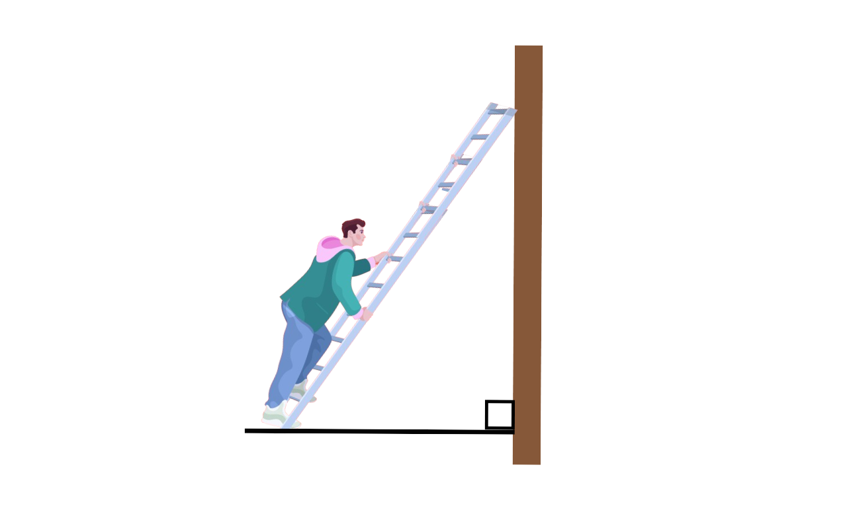

We can now use the length of the ladder and the distance to the base to determine the vertical height(h).

* Forming right angles

Back in the day, when Egyptians wanted to divide land into rectangular plots for cultivation and other purposes, they used a clever approach to accurately create right angles.

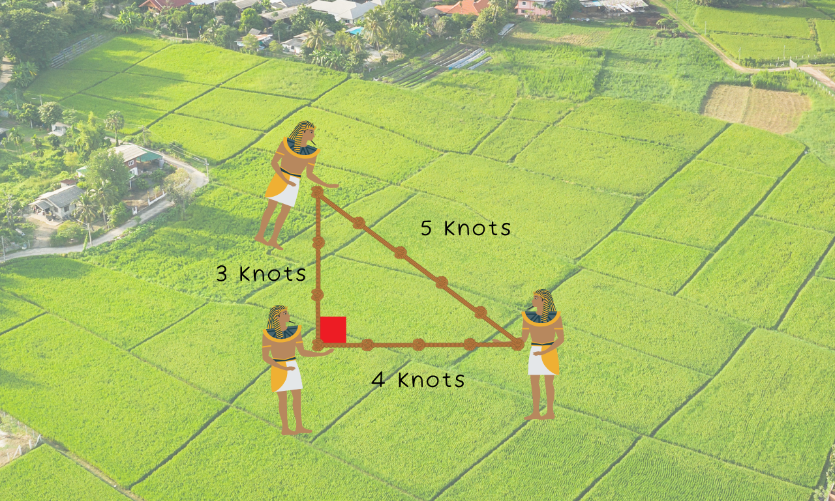

They formed triangles using ropes with side lengths that fit the Pythagorean theorem (Pythagorean triples such as 3, 4, and 5). By ensuring the lengths of the sides of the triangle adhered to this relationship, they could construct perfect right angles and create precise rectangular plots.